Hands of Straights
Problem Statement: You are given an array of integers hand, where hand[i] is the value on the i-th card that Alice owns. Alice wants to split her entire hand into groups such that: every group contains exactly groupSize cards, and the card values in each group form a sequence of groupSize consecutive integers (e.g. [3, 4, 5], [10, 11, 12, 13]).
Examples
Input : hand = [1,2,3,6,2,3,4,7,8], groupSize = 3
Output : True
Explanation : One possible partition is [1,2,3] [2,3,4] [6,7,8].
Algorithm
To determine whether a hand of cards can be rearranged into groups of size `groupSize`, we can sort the cards and always try to build a group starting from the smallest available card. We greedily check if the next `groupSize - 1` consecutive cards exist and reduce their count. A `TreeMap` (in C++ or Java) or a sorted map can help maintain keys in sorted order while efficiently accessing and updating the card counts.
- Check if total number of cards is divisible by groupSize; if not, return false.
- Store the frequency of each card in a sorted data structure.
- Iterate over the sorted keys (card values) from smallest to largest.
- For each key, try to form a group of groupSize starting from that key.
- If there are not enough cards to build a group, return false.
- Decrement the counts for each card used in the group.
- If all groups are successfully formed, return true.
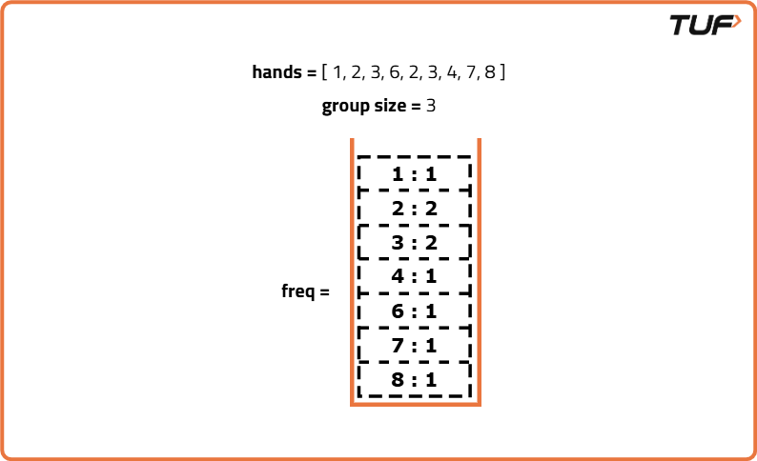

class Solution {
public boolean isNStraightHand(int[] hand, int groupSize) {

// If total cards can't be divided evenly, return false
if (hand.length % groupSize != 0) return false;

// Store the frequency of each card
TreeMap<Integer, Integer> freq = new TreeMap<>();
for (int card : hand) {
freq.put(card, freq.getOrDefault(card, 0) + 1);
}

// Loop through all keys in the map
while (!freq.isEmpty()) {

// Start of the current group
int start = freq.firstKey();

// Number of groups to form starting from this card
int count = freq.get(start);

// Try to build a group of size groupSize
for (int i = 0; i < groupSize; i++) {
int card = start + i;

// If the card is not present or has fewer frequency
if (!freq.containsKey(card) || freq.get(card) < count) return false;

// Decrease the frequency
if (freq.get(card) == count) freq.remove(card);
else freq.put(card, freq.get(card) - count);
}
}

// All groups formed successfully
return true;
}
}
Time Complexity:O(N log N) , where N is the number of cards. We insert each card into a map which takes log N time per insertion. Then, for each unique card, we attempt to form a group of size groupSize, and this check involves accessing up to groupSize elements in the map, each in log N time.
Space Complexity: O(N), because we store the frequency of each unique card in a map. In the worst case, all cards are unique, so the map can hold up to N entries.

